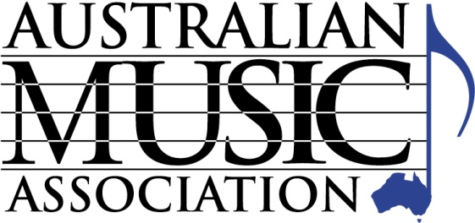
AUSTRALIAN MUSIC ASSOCIATION
PO Box 1035
Huntingdale, Victoria 3166

Tel (03) 9254 1019 Fax (03) 8610 1936
Email info@australianmusic.asn.au

ASSOCIATE MEMBERSHIP PAYMENT FORM

Company Name:

Full year membership - $ 255.00 (incl GST)

Note 5% discount for fees paid by end July 2018
- Pay by July 31, 2018 and pay $242.25

Payment Method (please tick the appropriate payment method)

 Payment by EFT

EFT Details: Account Name: Australian Music Association
Bank: ANZ BSB: 013 427, Account no: 4404 82437

  Cheque (cheques payable to ‘Australian Music Association’)

 Payment by Credit Card (We do not accept AMEX)

Visa Mastercard

Card Number:

Amount: Expires: CVV

Name as it appears on card:

Signature:

ABN: 58 026 169 284

Or pay online at www.australianmusic.asn.au/payment-page (Include your business name and membership number in the reference field)

