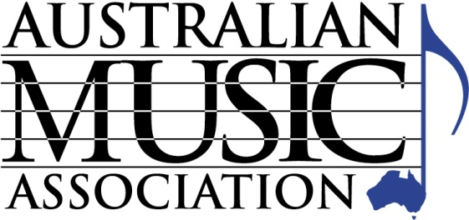
AUSTRALIAN MUSIC ASSOCIATION
PO Box 1035
Huntingdale, Victoria 3166

Tel (03) 9254 1019 Fax (03) 8610 1936
Email info@australianmusic.asn.au

WHOLESALE MEMBERSHIP PAYMENT FORM

Company Name:

Please tick the relevant box and your selected payment option,
Note 5% discount for fees paid by end July 2018

Number of employees - Wholesale Division Please tick the relevant box and your selected payment option

1 - 4 $990 ($940 if paid by 31 July 2018) * or $82.50 per month ($990.00 total)
5 - 10 $1,980 ($1,880 if paid by 31 July 2018) * or $165.00 per month ($1,980.00 total)
11 - 20 $3,960 ($3,760 if paid by 31 July 2018) * or $330.00 per month ($3,960.00 total)
21 or more $5,940 ($5,643 if paid by 31 July 2018)* or $495.00 per month ($5,940.00 total)
* All fees include GST
Payment Method (please tick the appropriate payment method)

Full payment upfront by EFT

Monthly Instalments by EFT (these must be set up as a regular payment with your bank)

EFT Details: Account Name: Australian Music Association
Bank: ANZ BSB: 013 427, Account no: 4404 82437

Cheque (cheques payable to ‘Australian Music Association’)

Full payment upfront by Credit Card

Monthly Instalments by Credit Card (2.4% surcharge applies to instalments)

Visa Mastercard

Card Number:

Amount: Expires: CVV

Name as it appears on card:

Signature:

ABN: 58 026 169 284

Or pay online at www.australianmusic.asn.au/payment-page (Include your business name and invoice number in the reference field)

