𝗖𝗥𝗘𝗔𝗧𝗘 𝗬𝗢𝗨𝗥 𝗢𝗪𝗡 𝗦𝗧𝗔𝗚𝗘 on Make Music Day June 21, 2021 and don’t forget to REGISTER so we know all about your event! Make Music Day is a free global D-I-Y Music Festival on June 21 for musicians of all levels, shapes, sizes and genres. Create Your Own Stage, wherever you are. Join us and 100’s of countries around the world to make music on June 21. Register your event HERE: https://makemusicaustralia.org.au/ #MAKEMUSICDAY #MAKEMUSICOZ

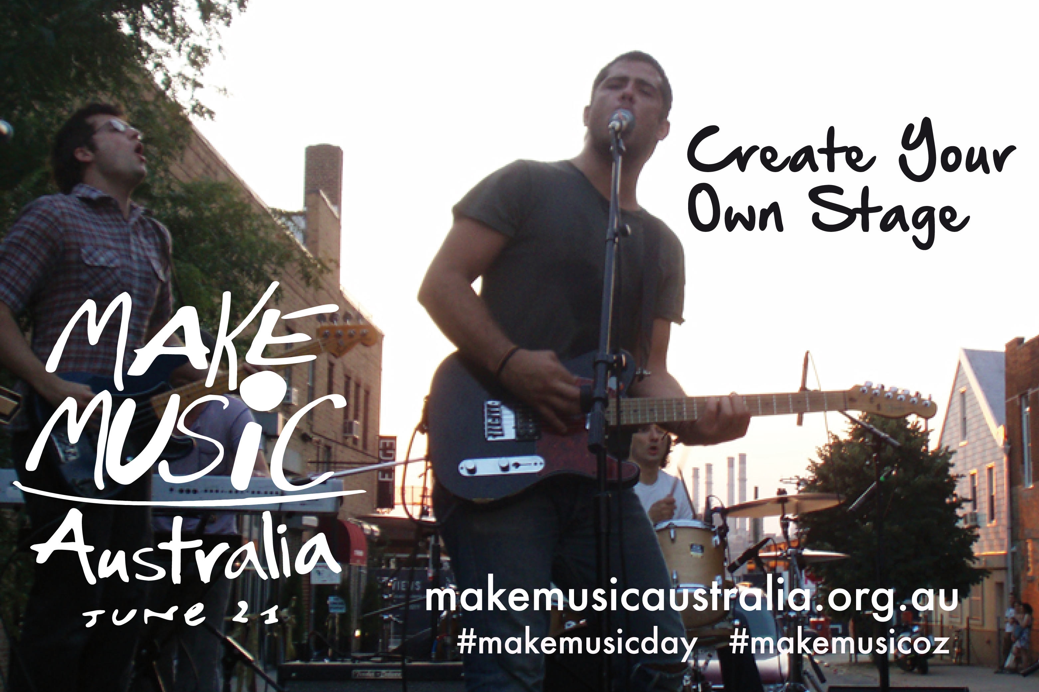

Head to the park and 𝗖𝗥𝗘𝗔𝗧𝗘 𝗬𝗢𝗨𝗥 𝗢𝗪𝗡 𝗦𝗧𝗔𝗚𝗘 on Make Music Day June 21, 2021 and don’t forget to REGISTER so we know all about your event! Make Music Day is a free global D-I-Y Music Festival on June 21 for musicians of all levels, shapes, sizes and genres. Create Your Own Stage, wherever you are. Join us and 100’s of countries around the world to make music on June 21. Register your event HERE: https://makemusicaustralia.org.au/ #MAKEMUSICDAY #MAKEMUSICOZ

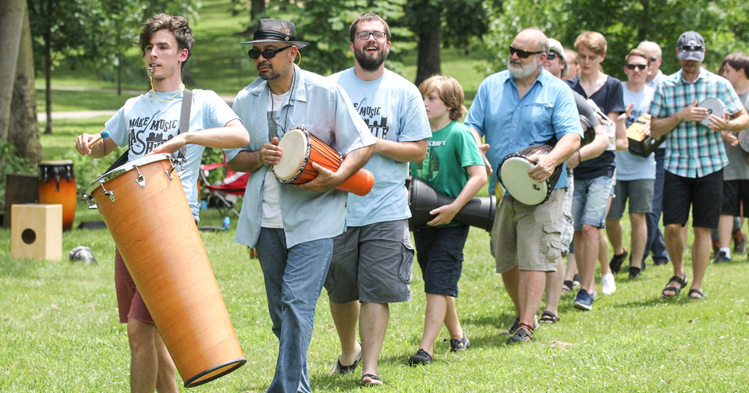
Jam outside your home and 𝗖𝗥𝗘𝗔𝗧𝗘 𝗬𝗢𝗨𝗥 𝗢𝗪𝗡 𝗦𝗧𝗔𝗚𝗘 on Make Music Day June 21, 2021 and don’t forget to REGISTER so we know all about your event! Make Music Day is a free global D-I-Y Music Festival on June 21 for musicians of all levels, shapes, sizes and genres. Create Your Own Stage, wherever you are. Join us and 100’s of countries around the world to make music on June 21. Register your event HERE: https://makemusicaustralia.org.au/ #MAKEMUSICDAY #MAKEMUSICOZ

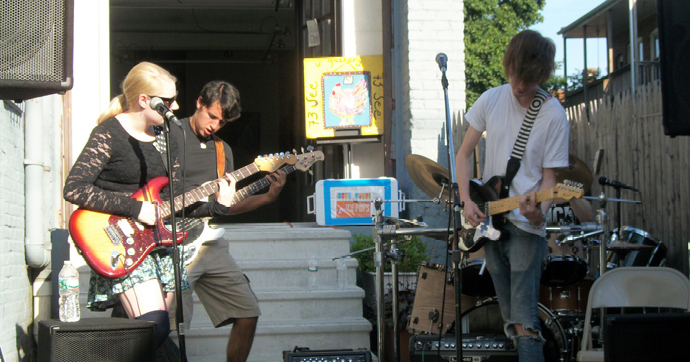

Get together with your friends and 𝗖𝗥𝗘𝗔𝗧𝗘 𝗬𝗢𝗨𝗥 𝗢𝗪𝗡 𝗦𝗧𝗔𝗚𝗘 on Make Music Day June 21, 2021 and don’t forget to REGISTER so we know all about your event! Make Music Day is a free global D-I-Y Music Festival on June 21 for musicians of all levels, shapes, sizes and genres. Create Your Own Stage, wherever you are. Join us and 100’s of countries around the world to make music on June 21. Register your event HERE: https://makemusicaustralia.org.au/ #MAKEMUSICDAY #MAKEMUSICOZ

Get your school band to perform and 𝗖𝗥𝗘𝗔𝗧𝗘 𝗬𝗢𝗨𝗥 𝗢𝗪𝗡 𝗦𝗧𝗔𝗚𝗘 on Make Music Day June 21, 2021 and don’t forget to REGISTER so we know all about your event! Make Music Day is a free global D-I-Y Music Festival on June 21 for musicians of all levels, shapes, sizes and genres. Create Your Own Stage, wherever you are. Join us and 100’s of countries around the world to make music on June 21. Register your event HERE: https://makemusicaustralia.org.au/ #MAKEMUSICDAY #MAKEMUSICOZ

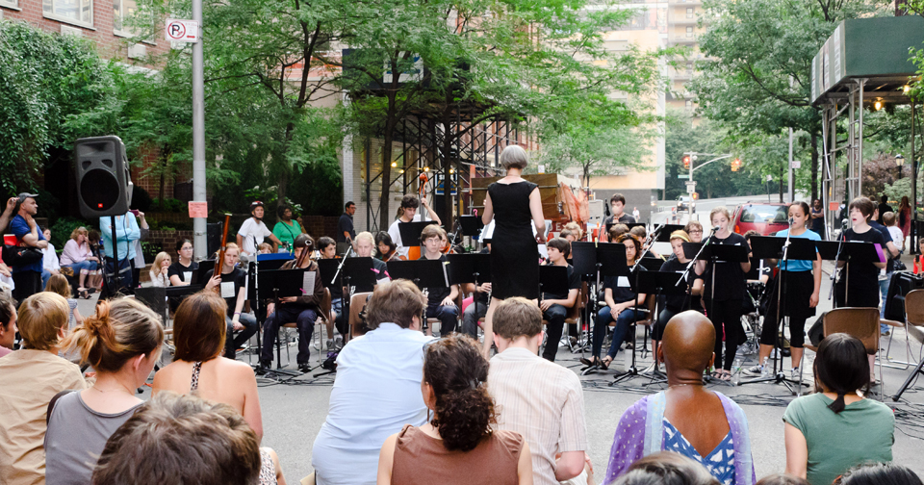

Join a Choir and 𝗖𝗥𝗘𝗔𝗧𝗘 𝗬𝗢𝗨𝗥 𝗢𝗪𝗡 𝗦𝗧𝗔𝗚𝗘 and sing on Make Music Day June 21, 2021 and don’t forget to REGISTER so we know all about your event! Make Music Day is a free global D-I-Y Music Festival on June 21 for musicians of all levels, shapes, sizes and genres. Create Your Own Stage, wherever you are. Join us and 100’s of countries around the world to make music on June 21. Register your event HERE: https://makemusicaustralia.org.au/ #MAKEMUSICDAY #MAKEMUSICOZ

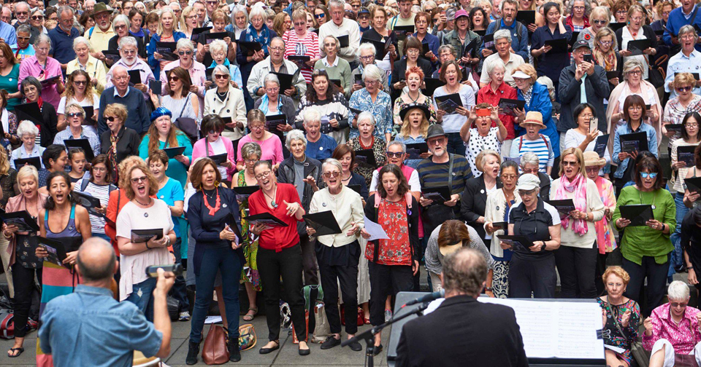
Get the Band together and 𝗖𝗥𝗘𝗔𝗧𝗘 𝗬𝗢𝗨𝗥 𝗢𝗪𝗡 𝗦𝗧𝗔𝗚𝗘 on Make Music Day June 21, 2021 and don’t forget to REGISTER so we know all about your event! Make Music Day is a free global D-I-Y Music Festival on June 21 for musicians of all levels, shapes, sizes and genres. Create Your Own Stage, wherever you are. Join us and 100’s of countries around the world to make music on June 21. Register your event HERE: https://makemusicaustralia.org.au/ #MAKEMUSICDAY #MAKEMUSICOZ

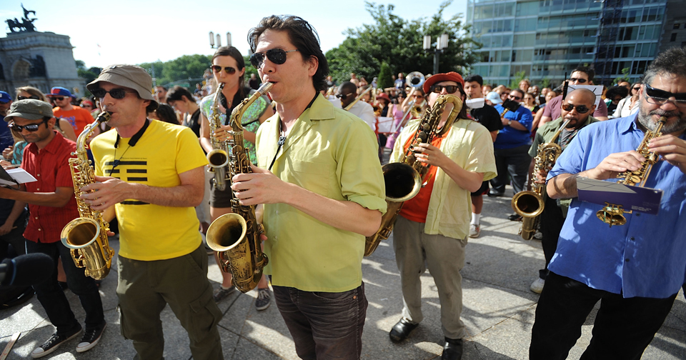
Get the Band together and 𝗖𝗥𝗘𝗔𝗧𝗘 𝗬𝗢𝗨𝗥 𝗢𝗪𝗡 𝗦𝗧𝗔𝗚𝗘 on Make Music Day June 21, 2021 and don’t forget to REGISTER so we know all about your event! Make Music Day is a free global D-I-Y Music Festival on June 21 for musicians of all levels, shapes, sizes and genres. Create Your Own Stage, wherever you are. Join us and 100’s of countries around the world to make music on June 21. Register your event HERE: https://makemusicaustralia.org.au/ #MAKEMUSICDAY #MAKEMUSICOZ
